1.Create a React application that implements routing using react-router-dom.
The application should have three pages: Home, About, Contact
Configure routing so that each page is displayed on its respective URL.
Hints:
- Install react-router-dom
- Use BrowserRouter as wrapper
- Use Routes and Route
- Create separate components for each page
CODE:
OUTPUT:
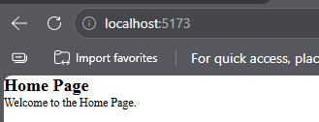
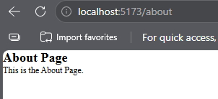
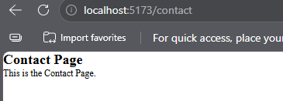
2.Create a navigation bar that allows users to switch between pages using: Link, NavLink
Also, highlight the active link using custom styling.
Hints:
- Use <Link> for basic navigation
- Use <NavLink> for active styling
- Use isActive property for styling active link
- Apply inline style or CSS classes
CODE:
OUTPUT:
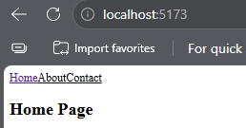
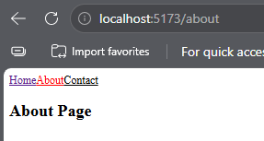
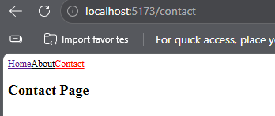
3.Implement a 404 Not Found page that is displayed when a user navigates to an undefined route.
Hints:
- Create a NotFound component
- Use path="*" in routing
- Place this route at the end
CODE:
OUTPUT:
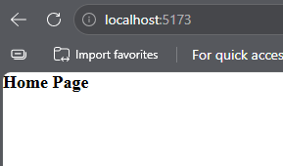
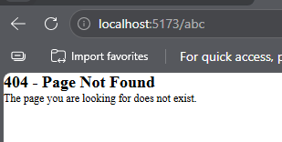
4.Create a dynamic route that displays user details based on URL parameter.
Example: /user/1, /user/2
Hints:
- Define route with :id
- Use useParams() hook
- Extract parameter and display it
CODE:
OUTPUT:
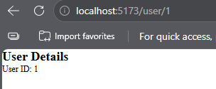
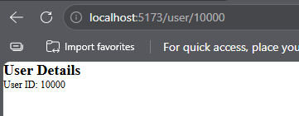
5.Create a simple Music Store application:
- Build a REST API using json-server
- Fetch data in React using fetch()
- Display list of songs (title & artist)
Hints:
- Create db.json file
- Run json-server
- Use useEffect() to fetch data
- Store data in useState()
- Use .map() to display list
CMD: npx json-server db.json --port 3001 and npm run dev
CODE:
OUTPUT:
